Soil Arthropods on BugNet:

Sample Acquisition, Preparation and Documentation
Inhalt
1. Trap Installation 2
2. Sample acquisition 2
3. Sample preparation 3
4. Sample Documentation 3
Sample Sheet 3
Camera 3
Image Capture Protocol 4

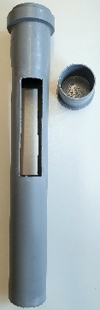
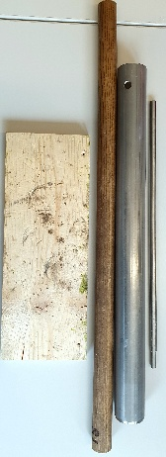
1. Trap Installation
2
1
Material:

- Soil corer set [1]
- nylon sledge hammer (ask workshop for borrowing – Urs Flütsch)
- PVC sleeves with socket plugs [2]
- Tape
- Gloves
- Slotted screwdriver

Install the PVC sleeve a few days before the actual measurement to allow the soil to settle and reduce disturbance effects.
- Drive the metal tube into the soil to the required depth (approx. 20 cm).
  - The upper end of the sampling window of the PVC sleeve should end just below ground level. Use tape to mark the correct depth on the metal tube.
- Insert the metal bar into the hole at the upper end of the tube. Twist and pull out the metal tube along with the soil core.
- To remove the soil core, insert the wooden stick into the upper opening of the tube, turn the tube upside down, and hit the stick against the wooden plate until the core is fully pushed out the other side. deposit soil core outside the plot
- If too many stones block the way, try again at least 10 centimetres from previous try.

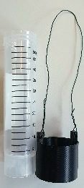
2. Sample acquisition
3
Material:

- Labels
- Falcon Tubes [3]

- Connectors with wire [3]
- EtOH 75% (1L ~40 Samples)

Each belowground pitfall trap is equipped with a labelled Falcon tube with 25mL EtOH 75%, which remains in the soil for 4 days.
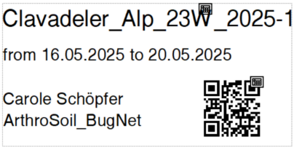
Label must contain:
- Plot ID_Sampling session
- Collection date (from–to)
- Operator name
- Project name
When inserting/removing the tube into the PVC sleeve:
- Be careful to avoid excessive soil entering the sample.
- Ensure the Falcon tube is fully inserted so the upper end of the connector aligns with the lower edge of the trap’s sampling window.
- Do not close the plug fully, as it is very hard to remove. Halfway is enough
- Use a wire hook to retrieve the Falcon tube after sampling.

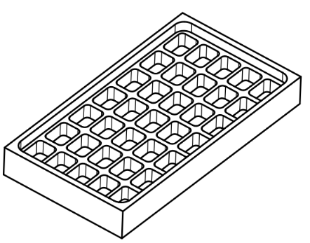
3. Sample preparation
1
Material:

- Customized counting tray (1)
technical drawing on GitHub
- EtOH 70% in a wash bottle
- Pipette
- Tweezers
- Fine brush

Steps:
- Gently shake the Falcon tube in circles to suspend the contents evenly.
  - If liquid is very turbid, do not shake! Decant it into the tray, replace turbid liquid with pipette without removing arthropods.
- Carefully pour the sample into the customized counting tray.
- Wash the falcon tube with EtOH until no organisms remain
- Use the pipette to evenly distribute organisms and fluid across all rectangles of the container.
- Remove clumps of dirt (discard).
- Remove any organisms not belonging to Acari or Collembola (put back in falcon tube).
  - Count and identify them to order level, enter information into sample sheet
- Use tweezers or a brush to separate remaining individuals that are clumped or poorly visible.

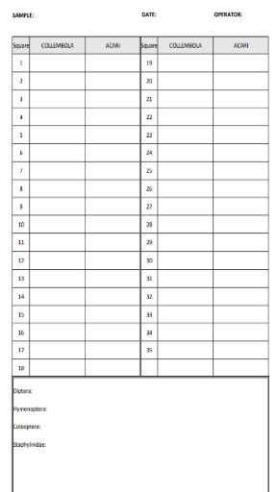
4. Sample Documentation

Sample Sheet
To support validation of the identification algorithm and provide a manual double-check, all individuals within each rectangle of a sample are counted and recorded in the sample sheet.
- Record the number of Acari and Collembola per rectangle.
- Other invertebrates should be counted for the entire sample and listed at the end of the sheet.
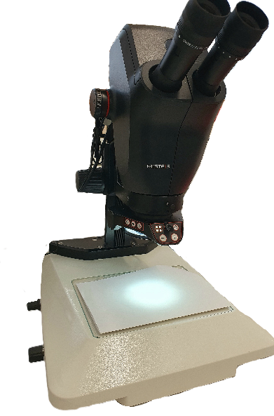
- After photographing each rectangle, cross out its corresponding number on the sheet to keep track of completed sections and avoid omissions.
Internal Computer
Polarisation Filter
LED Ringlight
White Paper Background

Camera
Specifics:
Leica Ivesta 3 (integrated camera): 10450981
Leica LED3000: 10450271
Leica TL3000 ergo: 10450690
The stereomicroscope has an internal computer with basic software. Using a connected display and mouse, images can be viewed, captured, and basic image settings adjusted.

Stereo magnifier Leica Ivesta 3 with LED ringlight and polarisation filter:
- Zoom: 1.00x (check on display, lower right corner) results in 273.5 Pixel/mm
- Light: Ringlight at max. brightness, all on
- Polarisation filter: Fixed position
- Background: use white paper under the tray
Camera Software:
- Set image quality to 12 MP (4:3)
- Adjust the sample name to format:
  - PlotID_SamplingSession (e.g. Bruech22A_2025-2)
- Perform white balance before imaging (put white paper under lens, then press the sun symbol). Repeat if light condition changes drastically within one sample. You might have to adjust colors manually, if sample liquid distorts the natural colour too much.

Image Capture Protocol
- Place the counting container so that the first rectangle is fully visible in the microscope camera view. Adjust focus if necessary.
⚠️ Note: The captured image includes ~1 mm more at the top and bottom than visible on screen.
- Take a picture using the camera icon . Wait until the image is saved before proceeding.
  - If possible check the public server, if a copy has been sent there
- Move to the next rectangle in the following order and repeat the process until all are documented.
- Images are saved temporarily to: P:\Leica_Ivesta_images.
  - Move them to your designated project folder (e.g. N:\ BugNet\SoilSample_Pictures for ML\Sampling session 2025_2)


Internal Computer
Polarisation Filter
LED Ringlight
White Paper Background

